2026 Foundation Summit
3.24.26
Kidron Bethel, North Newton, KS

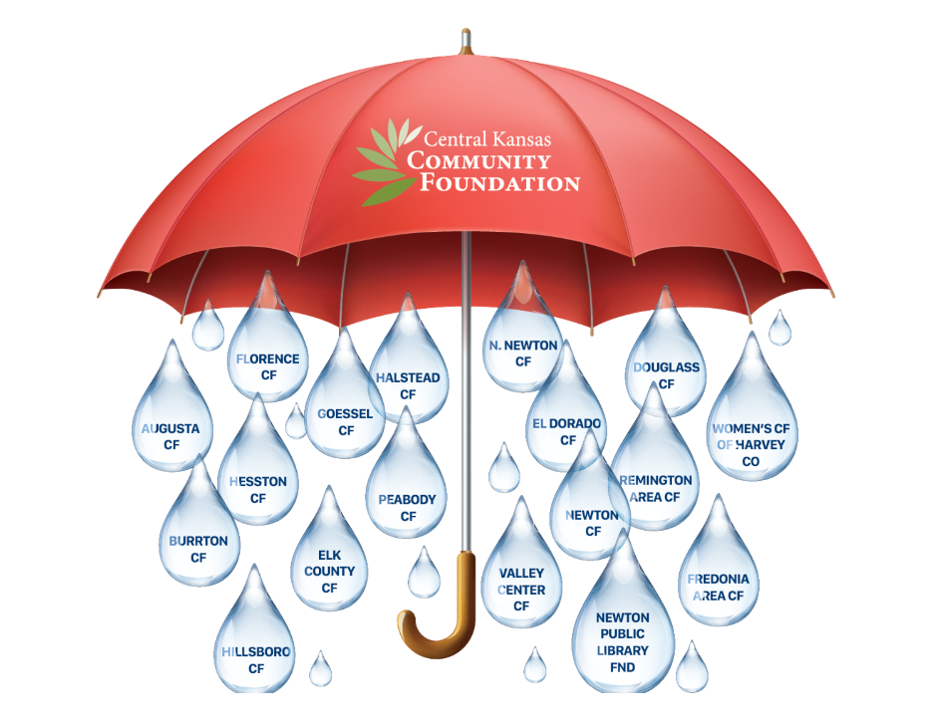
Welcome & Overview Heather Porter, CKCF Chair
Story Board/History Table Talk Angie Tatro, CEO
Terminology & Questions Raised
Becky Nickel, Affiliate Coordinator
Spotlight (Hillsboro)
Unity Framework
Keegan LeFerve, CKCF VC
Spotlight (Augusta)
Your Path to Service
Chad Hughbanks, Director
Spotlight (WCFHC)
Community Foundation Business Model Kelly Groening, CKCF Finance Chair
Working Lunch All
Visit Foundation Story Board Gallery
CKCF Business Model Kelly Groening, CKCF Finance Chair
Community Impact Roadmap
Leadership * Strategic Plan * Resources * Capacity Angie Tatro, CEO
Measuring Our Success – Benchmark Monitoring Chad Hughbanks, Director
Network Alignment All
Closing Remarks Heather Porter, CKCF Chair
Building Stronger Communities Through Charitable Giving

