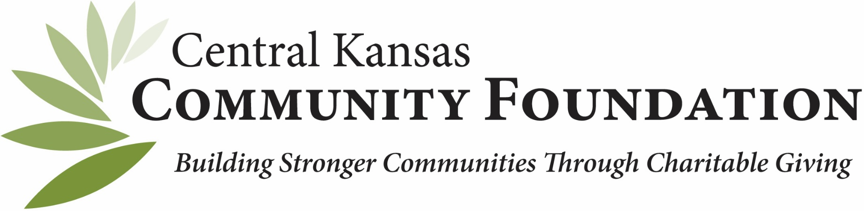
CENTRAL KANSAS COMMUNITY FOUNDATION
400 S. Main, Suite 100, Newton, KS 67114
316-283-5474
angie@centralkansascf.org
www.centralkansascf.org
MISSION
The Central Kansas Community Foundation (CKCF) strives on building stronger communities through charitable giving. CKCF acts as a steward, protecting charitable dollars, both now and in the future.
Central Kansas Community Foundation
CKCF is based in Newton, KS and is the host foundation to 18 affiliates in the central Kansas region, supporting rural philanthropy.
As the host and legal entity for the affiliates, CKCF supports administrative, legal, accounting, and investment services for all affiliates. CKCF is accredited with National Standards for U.S. Community Foundations® – the highest standards for philanthropic excellence.
CKCF Tax Identification Number: 48-1221368
Who Receives CKCF Distributions?
CKCF can make grant distributions to registered 501(c)(3) nonprofit organizations, governments, education organizations, religious organizations. Individuals or organizations that do NOT fall into one of the above entities are encouraged to partner with a fiscal agent in one of those categories.
Does CKCF Have an Investing, FEE, and SPENDING Policy?
Yes, to all. These policies are established by the Central Kansas Community Foundation Board of Directors and are applied consistently across every affiliate in the CKCF network.
General Questions
What is a community foundation?
Tax-exempt, non-profit, autonomous, non-sectarian, philanthropic institution broadly supported by the public.
Is a community foundation intended to serve the needs of only one donor?
No. A community foundation’s intent is to broadly serve a designated area. CFs can serve as an intermediary between donors and a wide range of charitable needs in the community.
Why are national standards important?
All community foundations receiving accreditation must meet 26 National Standards. These standards show that the community foundation strives to achieve operational excellence.
Can donors only give cash as a gift to a community foundation?
No. Gifts can take the form of different assets, such as:
- Commodities (e.g., livestock, grain, art, etc.)
- Stocks, bonds, and mutual funds
- Real estate and personal property
- IRAs and other retirement funds
- Bequests and Life Insurance

Starting a fund
Starting a fund with CKCF is a simple and rewarding process. You can work with our knowledgeable staff to determine the type of fund that best suits your goal. CKCF offers various fund options, including donor-advised funds, designated funds, and scholarship funds, providing flexibility and customization to meet your specific needs.

FUND GLOSSARY OF TERMS
Endowment Fund - fund where all donations are invested, and a portion of the investment returns is granted out. Also, called a permanent fund, legacy fund, or forever fund.
Expendable Fund - type of fund where both donations and income may be granted out.
Distribution - money that the Foundation awards to qualified organizations.
Fund Advisor - person(s) in charge of fund.
Memorandum of Understanding (M.O.U.) - signed agreement between a new fund advisor and CKCF that describes the use of a new fund. Not legally binding.

POPULAR FUND TYPES
Agency Fund - established by a nonprofit organization (agency) for the benefit of the nonprofit organization where the profits are distributed annually to the nonprofit organization to support operations, programs, etc. All donations must come from the agency.
Designated Fund - established by individual donors, not the agency itself, to benefit one or more not-for-profits. Open to public donations.
Donor Advised Fund - allows donors to make a tax-deductible contribution upfront and then recommend grants to charities over time.
Field of Interest Fund - fund established to be used for a specific, donor designated, charitable purpose such as education or health research.
Scholarship Fund - dedicated fund to provide financial assistance to students pursuing higher education.
Unrestricted Fund - fund that is not designated for any specific use by the donor.
CENTRAL KANSAS COMMUNITY FOUNDATION

