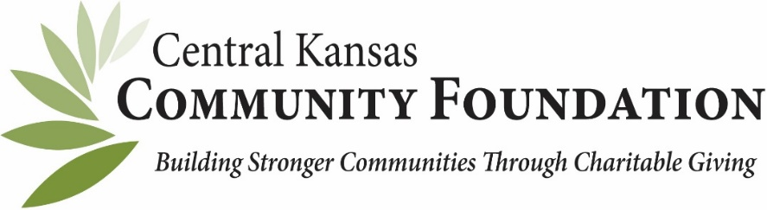

IN-KIND DONATION FORM

DONOR NAME ____________________________________________________________________________

DONOR ADDRESS__________________________________CITY, STATE, ZIP __________________________

DONOR PHONE NUMBER_____________________________________________________________

DONOR EMAIL_____________________________________________________________________

DESCRIPTION OF ITEM(S) OR SERVICES DONATED_________________________________________

__________________________________________________________________________________

__________________________________________________________________________________

__________________________________________________________________________________

ESTIMATED TOTAL VALUE OF ITEM(S) DONATED $________________________________________

Is this in-kind gift directly related to an event or campaign? __________________
IF YES, Name of event or campaign _________________________________________

Donor’s Signature_________________________________________________________________

Please return a copy to the Central Kansas Community Foundation and retain one for your files.

400 S. Main, Suite 100, Newton, KS 67114 or email (scanned version) to melinda@centralkanascf.org.
316-283-5474

Thank you for your generous contribution to __________________________________________________Fund managed by the Central Kansas Community Foundation (Tax ID 48-1221368) or one of its affiliates.
By signing this form, you confirm that you received no goods or services in exchange for your gift.
Consult your tax advisors as to the specific extent of deductibility.
This form will serve as your receipt for tax reporting purposes.
For further assistance, please contact Melinda Newell at melinda@centralkansascf.org

