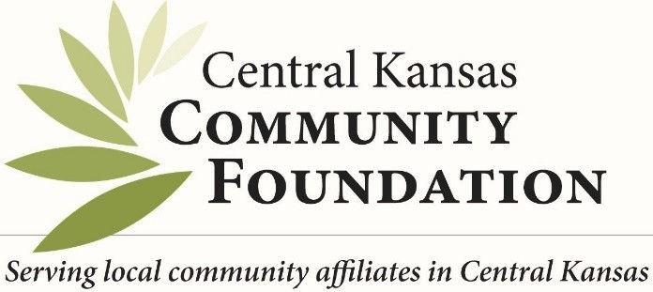
Accountant
Melinda Newell| melinda@centralkansascf.org 400 S Main, Suite 100, Newton, KS 67114
620-283-5474
In Office: Wednesday 10a-3p
Home Office Mon, Tues, Thurs and Fri 10a-3p

Find Forms at https://centralkansascf.org/affiliate-information/administration/
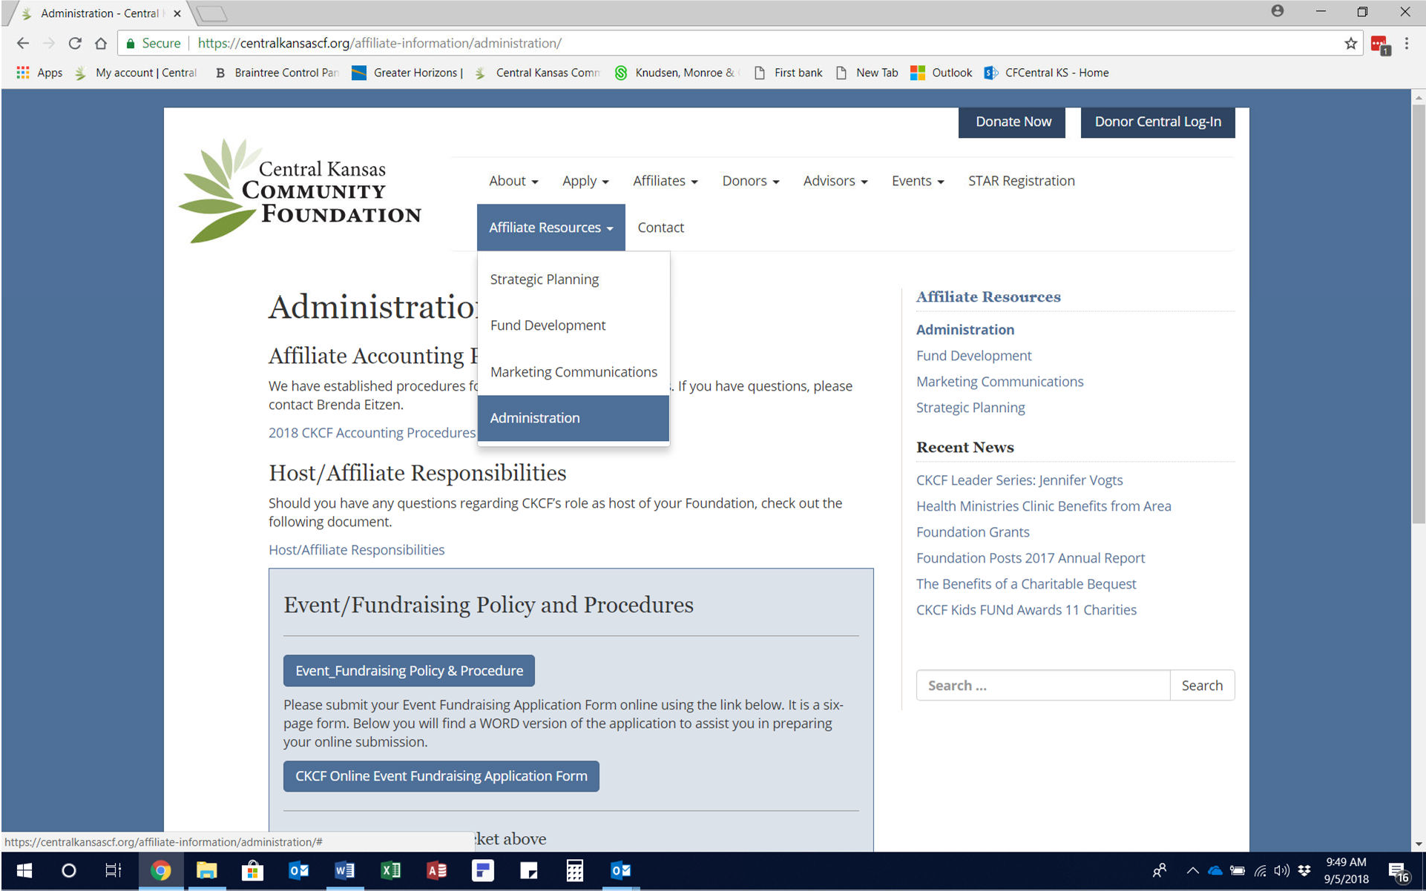

Payables:

Complete Distribution Recommendation Form and provide invoice and completed W-9 Form from vendor if new vendor. Send as a group to my email. Allow 10 days for processing. Payment goes directly to vendor from CKCF.

Donations*:

Checks/Cash: Complete Donation Deposit Record with cash/checks. All monies need to have Fund specific information. Mail or drop off at CKCF Office. Allow 10 days for processing/showing up in CommunitySuite, our online fund portal.
Commodity: Donation Deposit Record, check and settlement sheet from coop/elevator with donor name/address and fund name.
Stock: Contact Angie Tatro at angie@centralkansascf.org for form. Instructions vary based on type of stock.
*Co-Branded Donor receipt/thank you will be generated from CKCF office for all amounts. Affiliate expected to reach out and thank donor as well via email, phone, personal contact or thank you note. Affiliate to not mention donation amount in written correspondence.
In-Kind & Auction Donations**: Contact Melinda Newell for forms. Complete In-Kind & Auction Donation Form for all in kind donations. If donation above $100 threshold place all on Donation’s Item Detail Form and send to Melinda Newell with individual In-Kind & Auction Donation Forms as back up.
**Co-Branded Donor receipt/thank you will be generated from CKCF for amounts $100 and greater. Affiliate expected to reach out and thank donor via email, phone, personal contact or thank you note for all levels of in-kind or auction donations. Affiliate to not mention donation value in written correspondence.

Corporate Giving Program:

CKCF will tailor the forms per affiliate and corporation. Forms include Employee Payroll Deduction Program Instructions, Payroll Deduction Authorization CKCF Giving Form and 2022-2023 Payroll Deduction Spreadsheet. Contact Angie Tatro or Melinda Newell to acquire forms.

Grant Request:

Competitive Grant Cycles go through Kristie Diller but non-competitive (DAF, Designated, etc.) grant requests approved by respective affiliate board need:
Complete Distribution Recommendation Form and attach affiliate board minutes with approval to Kristie Diller.

Event & Fundraising Form:

Read Event Fundraising Policy & Procedure, complete Event fundraising Application Form (online Wufoo or word document) 90 days before event and at least 20 days before promotion. CKCF will review application and after approval affiliate to complete Event/Fundraising Donation Spreadsheet at event for any contributions. Use forms stated above for submitting donations and requesting payment of payables.
Note: Don’t forget about Crowd Consent Posters to display during award ceremonies and events. The poster is sufficient for day of or day after event social media posts. Best practice is to take a photo of the crowd consent poster at the event for our files. For all print media, you must obtain a written multi-media consent form from the participant. CKCF asks that you don’t use children in any social media or print media photos.

