WIENS AWARDED AGRICULTURE SCHOLARSHIP
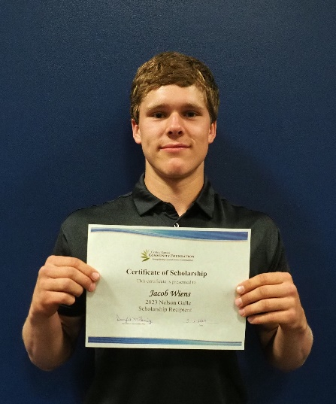

Jacob Wiens, Goessel High School graduating senior, was awarded the $1,000 Nelson Galle Endowed Scholarship at the school’s Award Assembly on May 12, 2023. This scholarship is presented to a GHS graduate pursing a degree in agriculture. He has been active in FFA and was on the state ag mechanics team which placed 5th. Throughout his high school career, he was a class officer, participated in football, basketball, and track and was a Student Council member.
He plans to attend Hutchinson Community College and study agri-business and agronomy, then transfer to Fort Hays State University or Kansas State University to pursue a four-year degree. Congratulations Jacob!

