2023 JNCCC SCHOLARSHIP WINNER
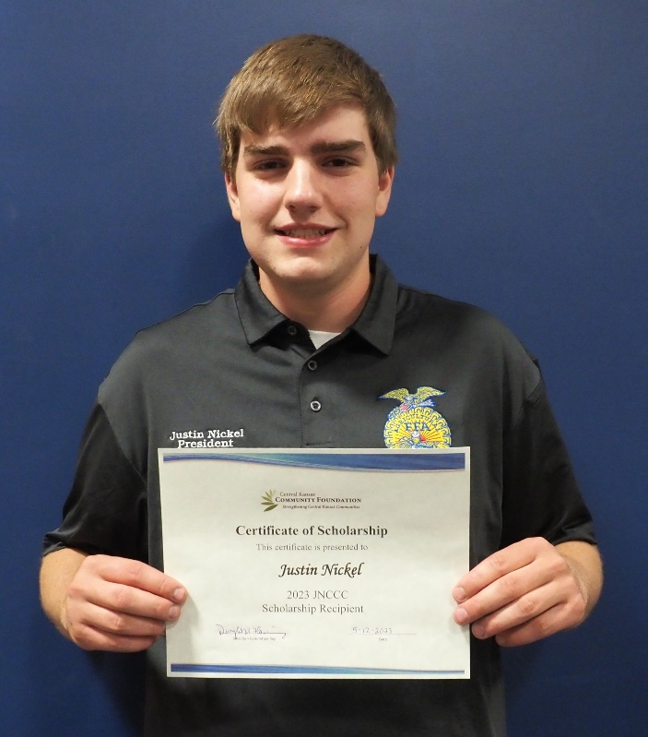
Congratulations to Justin Nickel, Goessel High School graduating senior, who was awarded a $500 JNCCC Scholarship from the Goessel Community Foundation at the High School Awards Assembly on May 12, 2023. Justin has been involved in FFA since his 8th grade and was president this year. He was a member of the State CDES Ag Mechanics team which placed 5th. Besides FFA, he has also held leadership positions in Student Council and been a class officer.
The Joyful Noise Community Child Care Scholarship was established to provide financial assistance to a graduate who plans to further their education at a private or public college/university. Justin plans to attend Hutchinson Community College and study agricultural diesel mechanics.

