NEWS RELEASE

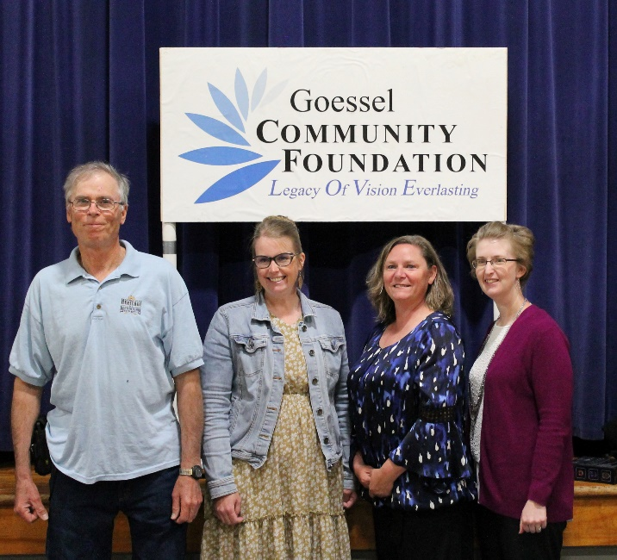
Photo: (Left to right) John Janzen, MH&AM; Lori Soo Hoo, FACT (Families And Communities Together);
Bonnie Gaeddert, Title 1, USD411; Sara Hiebert, Bethesda Home. Tracy Lowe, in absentia, Marion County Core Communities.

GOESSEL COMMUNITY FOUNDATION AWARDS $4,000 IN GRANTS

(Goessel, KS) The Goessel Community Foundation, an affiliate of Central Kansas Community Foundation, is pleased to announce the recent awarding of five 2023 Community Grants. Through the generosity of community donations to our Impact Fund, the Foundation was able to “give back to the community” through these local non-profits. Awards were presented at a Spring Celebration & Recognition Dinner at Goessel Elementary School on April 29, 2023 hosted by the Foundation Board. A complimentary meal prepared by Goessel Grocery & Deli and a humorous skit “AI and Fundraising: Not the Best Combination” given by Matt Lehman Wiens and Matt Voth were also part of the event.

$1,000—Mennonite Heritage & Agricultural Museum from the Impact Fund for renovation to the 1906 Preparatory School deck, stairs, stair rails, and handicap accessible ramp reconstruction.

$1,000—Bethesda Home $960 from the Goessel Senior Endowment and $40 from the Impact Fund to supplement expenses for the Friendship Meal Program. The recipients pay for one-third of the cost, with the remainder covered by grants, donations, and Bethesda.

$1,000—Goessel USD 411 for Early Childhood Family Engagement Night (Title 1) from the Impact Fund for family engagement opportunities and education activities for parents of pre-school age children. This event is an evening with many hands-on activities that allow families to get acquainted with resources which can assist educational needs early in life.

$500—Families & Communities Together for the Marion County Dolly Parton Imagination Library from the Impact Fund which provides families with children ages 0-5 a free age-appropriate book each month until the child reaches age 6. Books include directions and activities so parents have the means to read, interact, and connect with their children.

$500—Marion County Core Community from the Impact Fund for funding Youth Core Ministries. Their mission is to forever transform communities through leading kids to Jesus, connecting them to caring adults and wrapping around families to solve poverty.

Each year, our Impact Fund continues to grow. This year the fund reached approximately $108,000 which allowed us to increase our grant amount over previous years. To help us give even larger and/or more grants, and possibly take advantage of a matching grant opportunity, donations should be sent to GCF, PO Box 244, Goessel, KS 67053 or on-line at bit.ly/donate-goesselcf.
# # #

