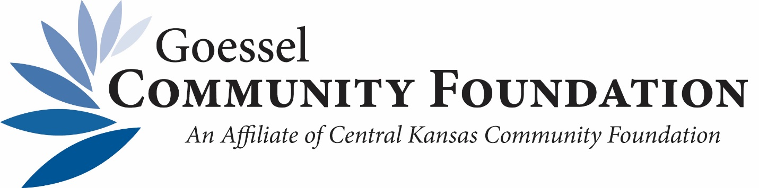
HISTORICAL SCHOLARSHIP RECIPIENTS
JNCCC Scholarship
2022: Rachael Zogleman and Kaleigh Guhr
2021: Kale Funk
2020: Alexandria Nickel
2019: Layci Foese
2018: Madeline Meier
2017: Gentry Thiesen
2016: Rebekah Herrel
2015: Sarah Booth
2014: Mark Schmidt & Jacob Herrel

Karen Rae McIntosh Teaching Scholarship
(Closed after 2019)
2019: Layci Froese
2018: No recipients
2017: Joshua Schmidt
2016: Aleena Cook
2015: Sarah Booth
2014: Kara Schmucker

Nelson Galle Endowed Agriculture Scholarship
2022: Caiden Duerksen

