2022 JNCCC SCHOLARSHIP WINNERS
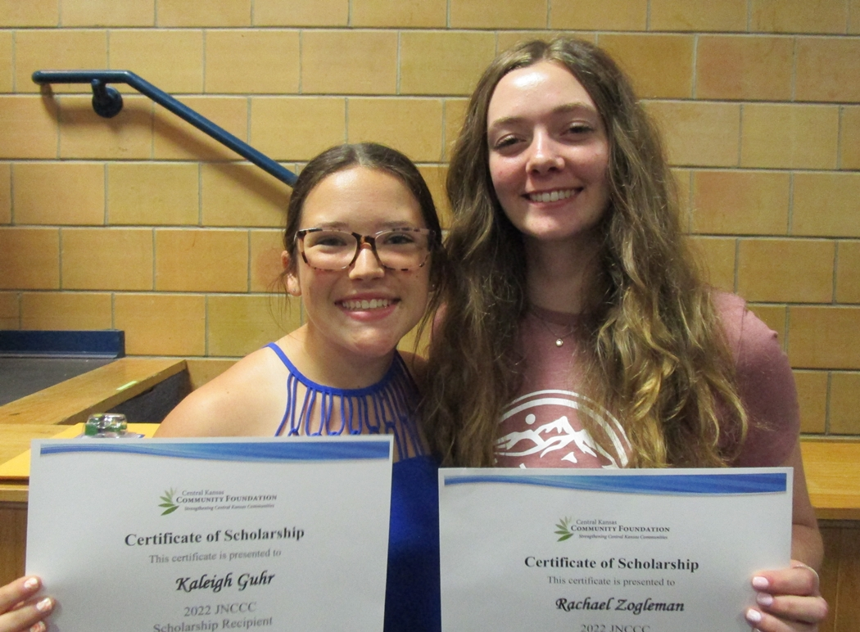

Congratulations to Kaleigh Guhr and Rachael Zogleman, Goessel High School graduating seniors, who were each awarded a $700 JNCCC Scholarship from the Goessel Community Foundation in May at the High School Awards Program.
The Joyful Noise Community Child Care Scholarship was established to provide financial assistance to a graduate who plans to further their education at a private or public college/university. Rachael is attending Fort Hays State University where she is pursuing a degree in medical diagnostic imaging. Kaleigh Guhr later decided not to attend college this year and declined the award.

