NEWS RELEASE

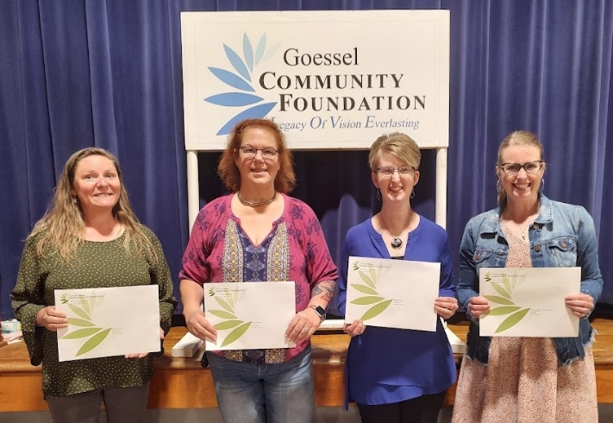
Photo: (Left to right) Bonnie Gaeddert, USD411; Tracy Lowe, Marion County Core Community;
Sara Hiebert, Bethesda Home; Lori Soo Hoo, Marion County Dolly Parton Imagination Library.

GOESSEL COMMUNITY FOUNDATION AWARDS $3,100 IN GRANTS

(Goessel, KS) The Goessel Community Foundation, an affiliate of Central Kansas Community Foundation, is pleased to announce the recent awarding of four 2022 Community Grants. Through the generosity of community donations to our Impact Fund, the Foundation was able to “give back to the community” through these local non-profits. Awards were presented at a Spring Celebration & Recognition Dinner at Goessel Elementary School on April 30, 2022 hosted by the Foundation Board. A complimentary meal prepared by Goessel Grocery & Deli and a skit “Leave 5 in Goessel” given by Matt Lehman Wiens and Matt Voth were also part of the event.

$1,100—Bethesda Home $970 from the Goessel Senior Endowment and $130 from the Impact Fund to supplement expenses for the Friendship Meal Program. The recipients pay for one-third of the cost, with the remainder covered by grants, donations, and Bethesda.

$1,000—Goessel USD411 for Early Childhood Family Engagement Night from the Impact Fund for family engagement opportunities and education activities for parents of pre-school age children. It is an evening with many hands-on activities that allow families to get acquainted with resources which can assist educational needs early in life.

$500—Marion County Core Community from the Impact Fund for a “Getting Ahead Scholarship” for educational opportunities to find solutions for families facing poverty. Classes are offered to help end the cycle of generational poverty by building resources to lift themselves out of poverty.

$500—Marion County Dolly Parton Imagination Library from the Impact Fund which provides families with children ages 0-5 a free age-appropriate book each month until the child reaches age 6. The program provides books, directions, and activities so parents have the means to read, interact, and connect with their children.

Each year, our Impact Fund continues to grow. Our goal of reaching $125,000 for our Impact Fund, would allow for larger grants in the future. To help us reach this goal, donations should be sent to GCF, PO Box 244, Goessel, KS 67053 or on-line at bit.ly/donate-goesselcf.
# # #

