DUERKSEN RECEIVES FIRST
GALLE ENDOWED AGRICULTURE SCHOLARSHIP

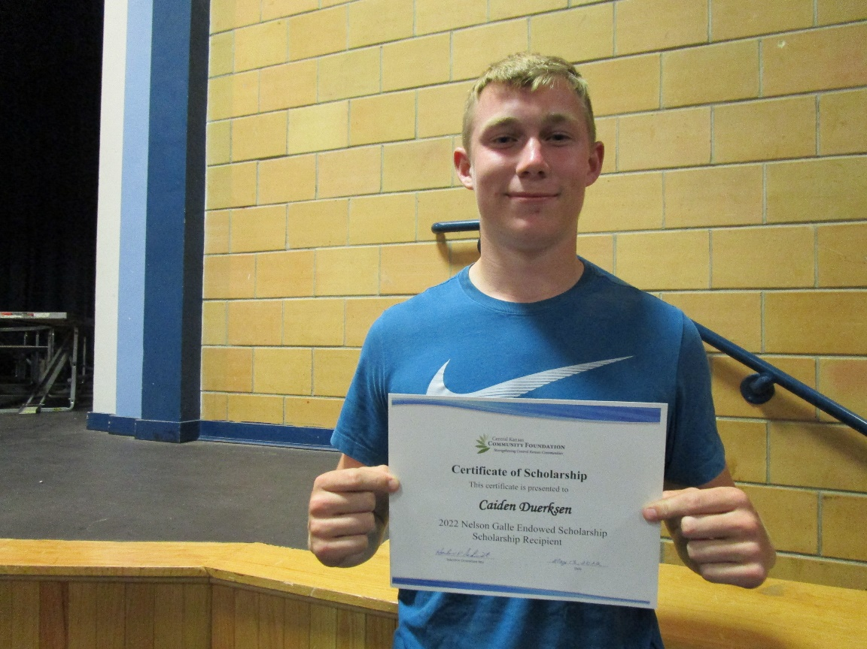
Congratulations to Caiden Duerksen, GHS Senior, who was awarded the first Nelson Galle Endowed Agriculture Scholarship in the amount of $1,000 in May at the High School Awards Program. Caiden is attending Kansas State University and majoring in ag tech management.
In the School year 1959-60, Nelson Galle, a recent K-State Graduate and former FFA State President, was hired to teach VoAg/FFA. Galle revamped the curriculum to also include students actively participating in competitive contests and leadership training, the format that continues to this day. In June 2021, the Goessel Community Foundation established this scholarship and solicited contributions from Goessel FFA alumni, graduates and friends of agriculture and raised $23,000.

