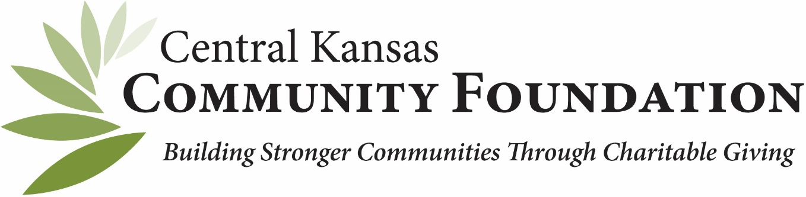
2022 Scholarship Cycles
Grants will open and close under designated time listed below. Dates are subject to change and some scholarships may not be
available if funds are underwater.

Applications available online at www.centralkansascf.org.

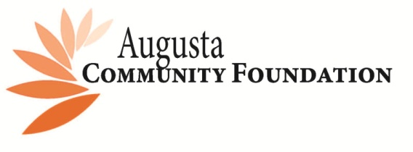
Scholarship Fund | Qualification | Date Open | Date Closed | Award Ceremony
Chelsea Gerbitz Memorial Scholarship Fund | Regional HS and College | 2/1/22 | 3/31/22 | Regional
May Gruver Scholarship Fund | Augusta High School | 2/1/22 | 3/31/22 | 4.25.22
Sally Annette (Souder) Puckett Scholarship Endowment | Augusta High School | 2/1/22 | 3/31/22 | 4.25.22
Vada-Vida Fletcher/Ketch Business Scholarship Fund | Augusta High School | 2/1/22 | 3/31/22 | 4.25.22
Walter and Sidney Ewalt Scholarship Fund | Augusta High School | 2/1/22 | 3/31/22 | 4.25.22

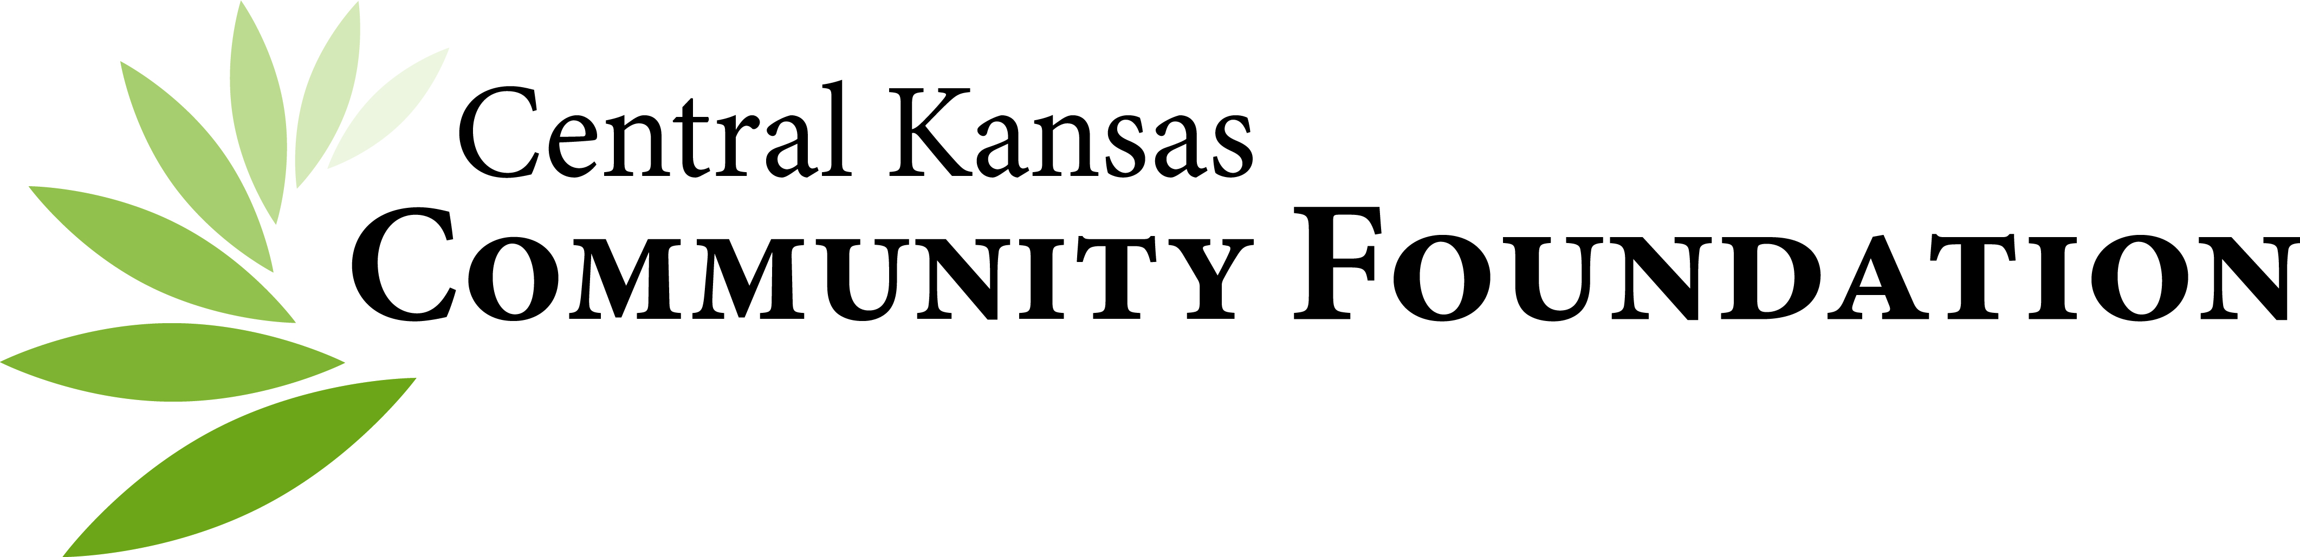
Scholarship Fund | Qualification | Date Open | Date Closed | Award Ceremony
Andover Area Chamber of Commerce Scholarship Fund | Andover High School / Andover Central High School / ECademy | 2/14/22 | 3/11/22 | Andover Central 4.27.22  Andover High  TBD
Seeds of Opportunity: The Richard and Leah May Ross Memorial Scholarship for Continuing Education Fund | Sedgwick High School | 2/14/22 | 3/11/22 | 5.11.22
Margaret L. Smith Decker Fund | Haven High  School | 2/14/22 | 3/11/22 | 5.9.22
Marissa Faith Miao Burghart Memorial Art Scholarship | Harvey or Shawnee County Seniors  Public, Private or Home School | 2/21/22 | 3/26/22 | TBD

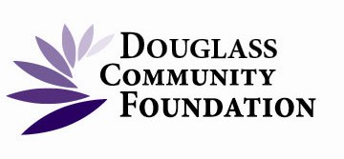
Scholarships | Qualification | Date Open | Date Closed | Award Ceremony
Dellsea Nachbor Memorial Scholarship Fund | Douglass High School | 3/14/22 | 4/8/22 | 5.6.22
Galen Haaga Memorial Scholarship Fund | Douglass High School | 3/14/22 | 4/8/22 | 5.6.22
Jeremy Allen Taylor Memorial Scholarship Fund | Douglas/Rose Hill High School, non-traditional students | 3/14/22 | 4/8/22 | Rose Hill 5.5.22  Douglass 5.6.22
Rusty Allen Inkeelar Scholarship Fund | Douglas High School | 3/14/22 | 4/8/22 | 5.6.22
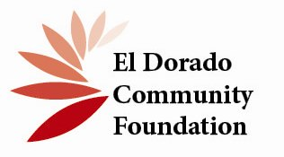
Scholarships | Qualification | Date Open | Date Closed | Award Ceremony
Clifford and Rubye Angleton Scholarship Fund | Butler County HS Senior or College Student | 3/7/22 | 4/1/22 | Regional  Circle High 5.18.22  El Dorado  5.6.22
Colin and Sally Rowell Memorial Scholarship Fund | Butler County, KS High Schools | 3/7/22 | 4/1/22 | Regional
Gary McEachern Memorial Scholarship Fund  NOT AWARDING In 2022 | HS Seniors of the Youth Leadership Butler Program
George Trimble Special Need Scholarship Fund | El Dorado High School | 3/7/22 | 4/1/22 | 5.6.22
Jenny Sundgren Baker Memorial Scholarship | Flinthills High School | 3/7/22 | 4/1/22 | 5.13.22
Wayne Willis Foundation Scholarship Fund | Regional: HS or college students furthering their careers through a degree in wildlife management or conservation of natural resources | 2/1/22 | 3/1/22 | Regional

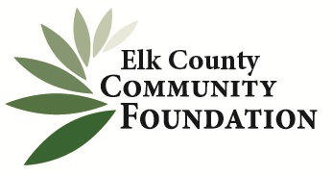
Scholarships | Qualification | Date Open | Date Closed | Award Ceremony
Ernest Frank Horn, Jr. Endowed Scholarship Fund | Elk Valley HS / West Elk HS | 3/7/22 | 4/1/22 | Elk Valley 5.14.22  West Elk 5.11.22
Jim and Steve Cunningham Nursing Scholarship Fund  NOT AWARDING in 2022 | West Elk High School

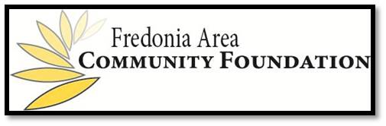
Scholarships | Qualification | Date Open | Date Closed | Award Ceremony
Fredonia High School Class of ’63 Legacy Project Scholarship | Fredonia High School seniors and/or Fredonia High School graduates | 2/1/22 | 2/28/22 | 4.27.22

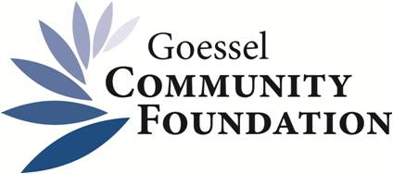
Scholarships | Qualifications | Date Open | Date Closed | Award Ceremony
JNCCC Scholarship Endowment Fund | Goessel High School seniors and non-traditional | 3/14/22 | 4/8/22 | 5.13.22
Nelson Galle Scholarship Endowment Fund | Goessel High Seniors and Graduates | 3/14/22 | 4/8/22 | 5.13.22

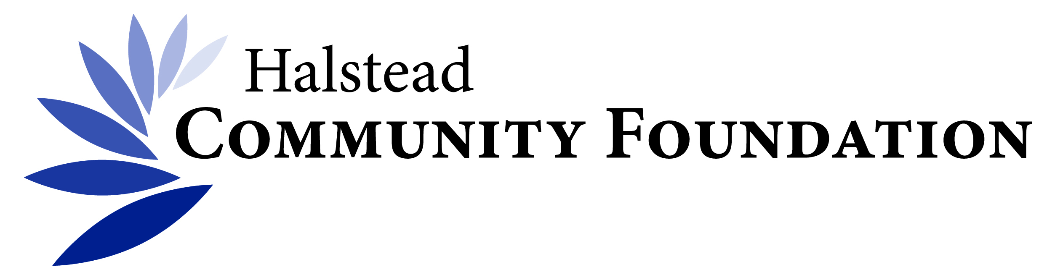
Scholarships | Qualifications | Date Open | Dated Closed | Award Ceremony
Bernice Wedel Memorial Scholarship Fund | Female Halstead High School senior | 3/1/22 | 3/26/22 | 5.11.22
Carolyn Taylor Memorial Scholarship Fund for Halstead High School* | Halstead HS seniors also attending Hutch Comm College | See HS counselor as this scholarship is not processed differently than other scholarships & has a different timeline
Charlsen Insurance Agency Scholarship Fund | Halstead HS seniors | 3/1/22 | 3/26/22 | 5.11.22
Clarence W Scharff Memorial Scholarship Fund  NOT AWARDING in 2022 | Halstead HS seniors and non-traditional
Fleetwood Scholarship Fund | Halstead High School or non-traditional | 3/1/22 | 3/26/22 | 5.11.22
Halstead Public Service Scholarship Fund | Halstead HS seniors | 3/1/22 | 3/26/22 | 5.11.22
Nightingale Scholarship Fund | Halstead HS Seniors | 3/1/22 | 3/26/22 | 5.11.22
Robert B Baumann Memorial Scholarship Fund | Harvey County HS or non-traditional students | 3/1/22 | 3/26/22 | Regional
Rupp Lawson Scholarship Fund | Halstead HS Seniors | 3/1/22 | 3/26/22 | 5.11.22
Delores Sexton Memorial Scholarship Fund | Halstead HS Seniors or non-traditional students | 3/1/22 | 3/26/22 | 5.11.22

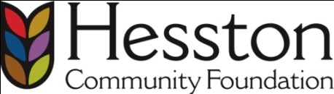
Scholarship | Qualifications | Date Open | Date Closed | Award Ceremony
Donna Schadler Scholarship Fund | Hesston HS seniors | 3/7/22 | 4/1/22 | 5.10.22
Excel Industries Inc. Scholarship Fund | Regional: Children or grandchildren of any current full-time employee of EXCEL Industries or its subsidiaries | 3/7/22 | 4/1/22 | Regional
G51 Scholarship Fund | Hesston HS seniors | 3/7/22 | 4/1/22 | 5.10.22

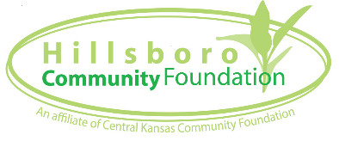
Scholarship | Qualifications | Date Open | Date Closed | Award Ceremony
C. M. Sextro Memorial Math Scholarship Fund | Hillsboro HS seniors | 3/1/22 | 3/26/22 | 4.25.22
Demarius Lives Scholarship Fund | Hillsboro HS seniors and non-traditional | 3/1/22 | 3/26/22 | 4.25.22
Earl Wineinger Memorial Scholarship Fund | Marion County HS seniors | 3/1/22 | 3/26/22 | 4.25.22
Free Press / Joel Klaassen Journalism Scholarship Fund | Marion County HS / Canton-Galva HS seniors | 3/1/22 | 3/26/22 | 4.25.22
Rod’s Tire and Service & Firestone Agricultural Solutions | Marion County seniors | 3/1/22 | 3/26/22 | 4.25.22
Gehring Family Tech Scholarship Fund | Marion County HS seniors & non-traditional | 3/1/22 | 3/26/22 | 4.25.22

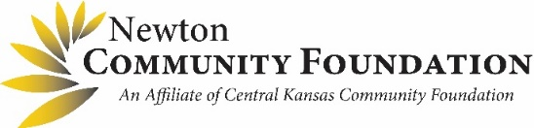
Brian Arellano Scholarship Fund | Newton HS seniors and/or non-traditional students | 2/21/22 | 3/26/22 | 4.27.22
Bonnie Selanders Scholarship Fund | Newton HS seniors and non-traditional | 2/21/22 | 3/26/22 | 4.27.22
Denise Lynn Oursler Memorial Scholarship Fund | Newton HS seniors | 2/21/22 | 3/26/22 | 4.27.22
E.S. Sanderson Scholarship Fund | Newton HS seniors | 2/21/22 | 3/26/22 | 4.27.22
Jean and Virginia Coleman Music Scholarship Fund | Newton High School seniors and/or non-traditional students | 2/21/22 | 3/26/22 | 4.27.22
Katherine Hanna Education Trust Endowment Fund | Newton HS seniors and/or non-traditional students | 2/21/22 | 3/26/22 | 4.27.22
Newton Area Women of the Year Scholarship Fund | Newton HS seniors or graduating residents of USD 373 | 1/1/22 | 2/15/22 | Recipient will be recognized at the NWOY Spring Brunch  4.23.22
Newton Lions Club Scholarship Fund | Newton HS Seniors | 2/21/22 | 3/26/22 | 4.27.22
Nygaard Family Scholarship Fund | Newton HS seniors and/or non-traditional students | 2/21/22 | 3/26/22 | 4.27.22
Snapp Family Scholars Fund | Newton HS seniors | 2/21/22 | 3/26/22 | 4.27.22
Vince Garcia Community Service Scholarship Fund  NOT AWARDING in 2022 | Newton HS seniors and/or non-traditional students

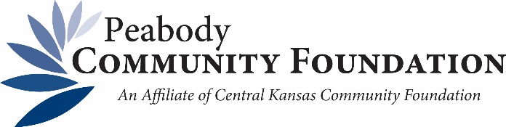
Scholarship | Qualifications | Date Open | Date Closed | Award Ceremony
Ewert Family Scholarship Fund | Peabody-Burns HS seniors | 3/7/22 | 4/1/22 | 5.15.22
Marilyn & Keith Harsh Memorial Scholarship Fund | Peabody-Burns HS seniors | 3/7/22 | 4/1/22 | 5.15.22
Keith & Marilyn Harsh Scholarship Fund | KS High Schools | 3/7/22 | 4/1/22 | Regional
Peabody United Methodist Church Scholarship Fund | Peabody-Burns HS seniors and regular attendee of Peabody United Methodist Church | 3/7/22 | 4/1/22 | 5.15.22

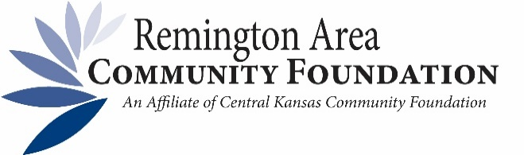
Scholarship Fund | Qualification | Date Open | Date Closed | Award Ceremony
Edna and Mae Mertz Scholarship Fund | Remington HS seniors | 2/1/22 | 2/25/22 | 4.28.22
John Edwards Scholarship Fund | Remington HS seniors | 2/1/22 | 2/25/22 | 4.28.22
Keith Sommers Scholarship Fund | Remington HS seniors | 2/1/22 | 2/25/22 | 4.28.22
Larry Brown Memorial Scholarship Fund | Remington HS seniors | 2/1/22 | 2/25/22 | 4.28.22
Novalis “Nick” or Pauline Toews Scholarship Fund | Remington HS seniors | 2/1/22 | 2/25/22 | 4.28.22
Pat Halabi Memorial Scholarship Fund | Remington HS seniors | 2/1/22 | 2/25/22 | 4.28.22
RD Allen Scholarship Fund | Remington HS seniors | 2/1/22 | 2/25/22 | 4.28.22
Tina Jo Wedel Burton Scholarship Fund | Remington HS seniors | 2/1/22 | 2/25/22 | 4.28.22

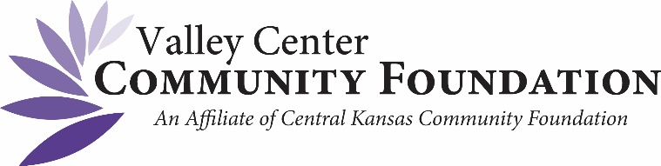

Riley Greenwood Memorial Scholarship Fund | Valley Center HS seniors | 3/1/22 | 3/26/22 | 4.27.22

If you have questions or need further information, please contact Kim Stahly.
CKCF Program Officer~ Scholarships, kim@centralkansascf.org or 316.283.5474.

