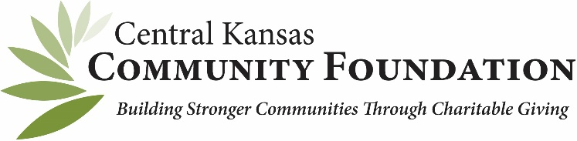

DISASTER PREPAREDNESS EDUCATION OPPORTUNITY

As you might know, Central Kansas Community Foundation has participated in a cohort group of community foundations from the Midwest region in learning about the philanthropic role of community foundations in disaster preparedness and response. CKCF has actively worked with our affiliate foundations to share our knowledge and support the establishment of disaster response funds for your organizations. We appreciate your investment and interest in this process; it is important work.
Through a grant opportunity provided to use from The Funders Network of Coral Gables, Florida, we want to offer you an opportunity to earn a $250 mini-grant from CKCF that can go into your community foundation’s disaster response fund. To qualify for the grant, the members of your board need to complete the following:
- Take home the packet of information for your community foundation that includes 100 magnets and 100 flyers which should be paired with a magnet.
- Find an opportunity to distribute these materials to people in your community. This could happen in a variety of ways-each member could take a stack and hand out to friends, the magnet/flyers could be handed out at a football/volleyball game, you could have a table with this information at a community event. The most important thing to remember is you want to get this information into people’s hands and emphasize two points to them:
- disaster preparedness is very important
- your local community foundation has a disaster response fund in place
- After you have distributed the 100 items, you will be asked to notify Susan Lamb, who coordinates disaster response for CKCF, and the $250 will be granted to your community foundation.
We believe this is a great opportunity for you to boost your fund and talk about an important topic to community members. Please contact Susan with questions at susan@centralkansascf.org

