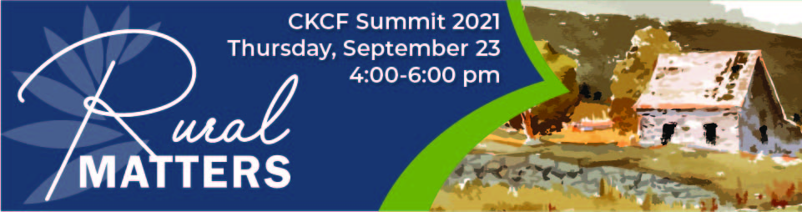

- Welcome (4:00 – 4:05 pm) Jennifer Vogt, CKCF Board Chair

- What Matters in Your Community (4:05 – 4:15 pm) Angie Tatro, Executive Director
- Rural Matters (4:15 to 4:45) Marci Penner, Kansas Sampler Foundation

- Break Out Session #1 (4:45 to 5:00) All
What about Rural Matters to you? How is your foundation addressing or how could they?

- Resources & Toolkit (5:00 to 5:15) Angie Tatro, Executive Director
  - Disaster Preparedness and Community Resiliency
  - National Standards
  - Getting and Giving – CKCF and Affiliate Historic Data
  - Central Kansas Impact Investing – Future Investments
  - Board Recruitment

- Break Out Sessions #2 (5:15 - 5:30 pm) All
What made an impact in your community this year? How can you build on it or pivot?

- Testimony of Giving 5:30-5:40 – Planned Giving Carol Duerksen, Goessel Kansas

- Break Out Sessions #3 (5:40 to 5:50 pm) All
Partner Sharing – What can you share and learn from person next to you?

- What Mattered ~ Call Out/Reflections (5:50 -6:00) Angie Tatro, Executive Director

- Final Thoughts/Adjourn 6:00 pm Becky Wolfe Vice Chair-Elect

