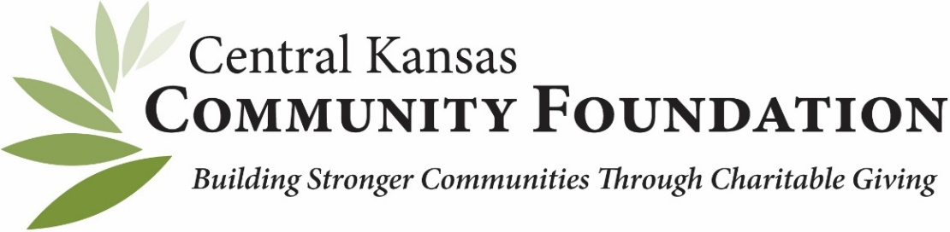

Agency/Organizational Fund Overview

Agency Fund (Options)

Agency Endowment: Your organization revocable authorizes the Foundation to manage the money in its fund. Your organization can request and receive the entirety of its assets back at with mutual approval between both boards of directors. The fund is recorded on your organization's books as an asset and on the Foundation books as an asset and a liability. All contributions to these funds must come from your organization directly. We cannot accept charitable gifts from individual donors to Agency Endowment Funds.

Strict Endowment: Your organization irrevocably gifts the fund and all future earnings to the Foundation in perpetuity. An annual payout consistent with our spending policy is designated to your organization. This option is best for organizations that want to assure donors that the endowment's principal will not be invaded, or those that want to honor a donor's bequest of an endowment fund. The Foundation can accept charitable gifts from individual donors to this type of Agency Endowment Fund.
Advantages to Non-Profit, Agency Fund
There are numerous advantages to a nonprofit agency fund:
- Low investment costs: Our large investment portfolio reduces the costs that individual funds often incur.
- Oversight: It is our fiduciary duty to ensure prudent investment of your assets. A highly experienced investment committee, consultant and staff oversee investment activity.
- Transparency: Statements, investment holdings, performance and total costs are reported quarterly. Monthly investment returns are available online. You can access your nonprofit fund information 24/7 through our easy and secure online portal.
- Access: You gain access to a diversified group of high quality, institutional investment managers not regularly available to most investors.
- Presentations: Foundation staff will provide presentations to board and other agency constituents regarding your fund(s).
- Compliance: We support your finance staff and auditors with necessary data for financial reporting and disclosures.
Alternative to Organization/Agency Fund is a Designated Fund
- Designated only for benefit of your organization, in whole or per program.
- Promote to Donors. Anyone can contribute and grow your fund.
- Financial Oversight is responsibility of the Foundation.
For questions or more information about starting a new fund, please contact:
Angie Tatro
Phone: (316) 283-5474
Email: angie@centralkansascf.org

