2021 SCHOLARSHIP WINNER

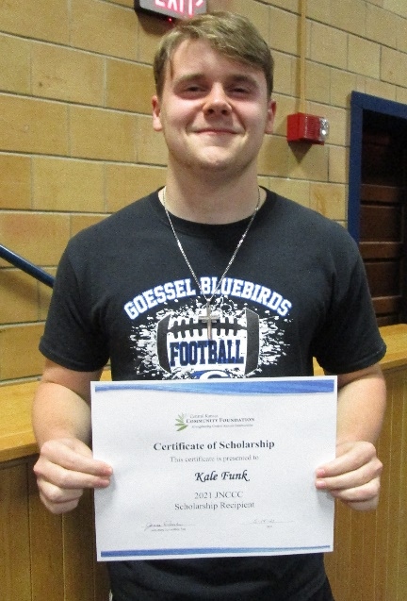

Kale Funk, a 2021 Goessel High School graduating senior, was awarded a $700 JNCCC Scholarship from the Goessel Community Foundation at the recent High School Awards Night. The Joyful Noise Community Child Care Scholarship was established to provide financial assistance to a graduate who plans to further their education at a private or public college/university. Kyle will be attending Hutchinson Community College in the fall with a major in business administration. Congratulations Kale.

