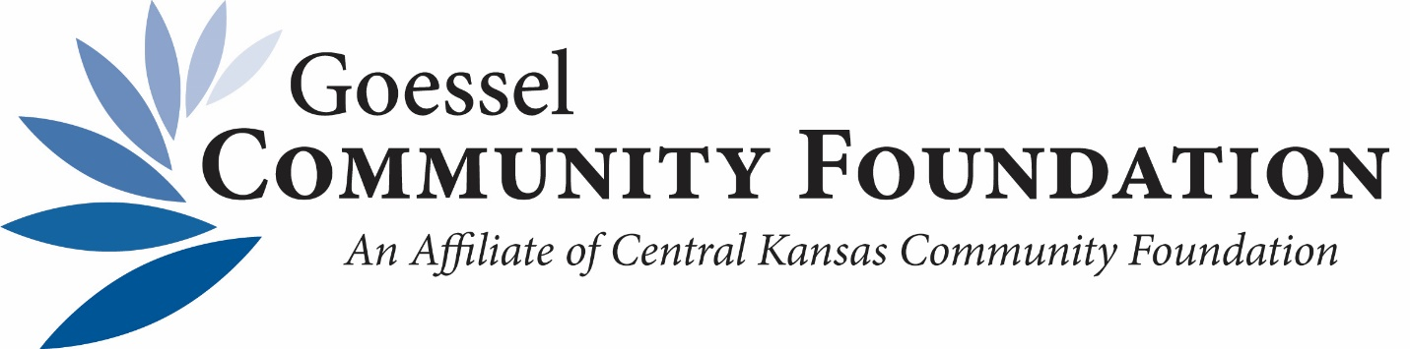

2021 Grant Recipients

$1,180—Bethesda Home from the Goessel Senior Endowment ($940) and Impact Fund ($240) to supplement expenses for the Friendship Meal Program.

$600—Goessel USD411 for CARES (Community Addressing Readiness for Everyone) from the Impact Fund for family engagement opportunities and education activities for parents of pre-school age children.

$600—Goessel Public Library from the Impact Fund to establish a permanent “Elaine Schroeder StoryWalk” along the sidewalk of Bethesda Home to promote reading for children and families.

$500—Circles Marion County from the Impact Fund for a “Getting Ahead Scholarship”. Core Community is about bringing families experiencing poverty together where they help create solutions to get people out of poverty.

$500—Marion County FACT (Families and Communities Together) from the Impact Fund for Family Financial Assistance Network (emergency financial assistance to households that are unable to pay for basic services necessary for family health and safety).

$250—CASA (Advocacy for the Goessel area) from the Impact Fund for serving victimized children of Goessel and Marion County.

Total Awarded: $3,630

