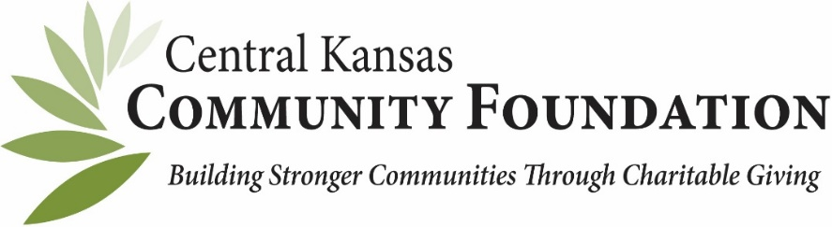
FOR OFFICE USE ONLY
Event Form # ________________________
Event/Campaign Name ________________
Voucher tied to campaign ______________

DISTRIBUTION RECOMMENDATION FORM

Request Type Date of Request:

o GRANT

o SCHOLARSHIP

o PAYABLE/REIMBURSEMENT (Include W-9 first time)

Fund Advisor/Selection Committee Representative Name: _ _____________________

Email: __________________________________________ Phone: _________________

Foundation Name: _ ___________________________________________

Fund Name: _ ________________________________________________

Amount: $ ___________________________________________________

Is this invoice directly related to an event or campaign? _____________
IF YES, Name of event or campaign _____________________________________________

Payee Information
Name:___________________________________________________
Street Address: ___________________________________________
City, State, Zip: ___________________________________________

If Interfund Transfer, fund to be reimbursed: _______________________

The check will be sent to payee unless otherwise provided instructions below. Please anticipate
7-10 business days once provided to CKCF for completion of any check request.

Instructions for mailing:

Requesters Name: _______________________ Signature: ___________________________

Please return a copy to the Central Kansas Community Foundation and retain one for your files.

301 N. Main, Suite 200, Newton, KS 67114 or email (scanned version) to melinda@centralkansascf.org and angie@centralkansascf.org
316-283-5474

Please attach back-up documentation that includes but is not limited to minutes, email communication, donor/committee member names, W-9, and this recommendation form.

