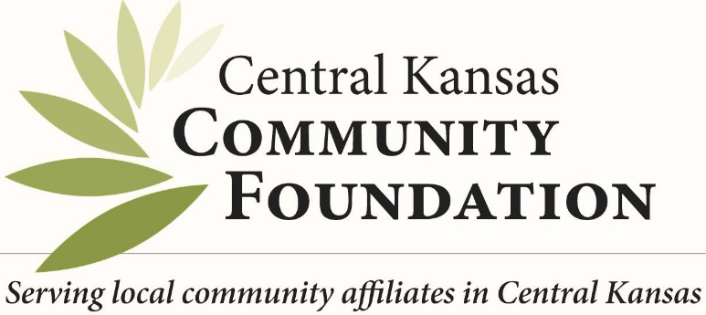

Top Ten reasons people choose to give through their local community foundations:

- We are a local organization with deep roots in the community

- Our professional staff has broad expertise regarding community issues and needs

- We provide highly personalized service tailored to each individual’s charitable and financial interests

- Our funds help people invest in the causes they care most about

- We accept a wide variety of assets and can facilitate even the most complex forms of giving

- We partner with professional advisors to create highly effective approaches to charitable giving

- We offer maximum tax advantages for most gifts under federal law

- We multiply the impact of gift dollars by pooling them with other gifts and grants

- We build endowment funds that benefit the community forever and help create personal legacies

- We are a community leader, convening agencies and coordinating resources to create positive change

Community foundations provide a simple, powerful, and highly personal approach to giving. We offer a variety of tools to help people achieve their charitable goals. To learn more about it, ask your financial advisor, or call the Central Kansas Community Foundation, Angie Tatro, executive director at 316-283-5474

www.centralkansascf.org

