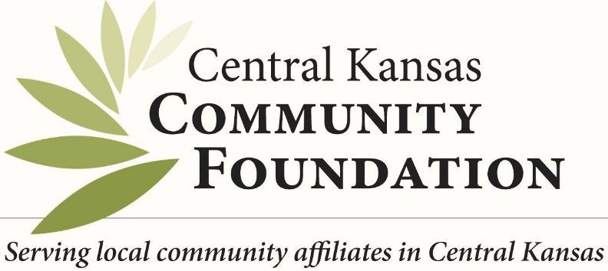
Frequently Asked Questions

Q. What is a community foundation?

- Community foundations are public charities that share a common goal: improving the quality of life in their geographic areas.
- Community foundations are repositories for permanent endowments as well as other charitable instruments.
- Individuals, families, businesses and organizations create charitable funds to help their community meet its needs. The foundation invests and administers these funds.
- Community foundations are overseen by a volunteer board of leading citizens and run by professionals with expertise in identifying their community’s needs.
- Community foundations often facilitate community-wide conversations about important community topics such as affordable housing, education and healthcare.
- Community foundations are a resource for nonprofit organizations, providing grants and technical assistance training in a wide variety of areas.

Q. Is Central Kansas Community Foundation and their Affiliate Foundations considered a "charity"?
Yes. Central Kansas Community is a charitable 501 (c) (3) organization under the tax code. As a Host Foundation our primary role is to encourage, channel and administer philanthropy to benefit effective organizations serving our Central Kansas Service Region that includes our affiliate community foundations. Most people give through the Foundation to the community by way of a charitable fund, administered by the Foundation. CKCF is the legal entity and holds the IRS 501 (c) (3) charitable designation.
Q. Who can give? Anyone. Donors to the Foundation are from a variety of backgrounds with a common commitment to the community's well-being.
Q. What's the minimum donation?
No gift is too small. Gifts of $25, $10, or even $1 can be made to an existing named fund such as an organization, field of interest or scholarship fund, or to our unrestricted grant fund as memorials or charitable contributions. That is what makes this truly a community foundation. Minimums do exist for those who wish to establish a named fund.

Q. Why establish a fund with the foundation instead of giving directly to a favorite charity?
Donors who want to ensure that their gifts will do the most good in the community and support organizations over the long term, find that community foundations offer them the expertise, flexibility and financial resources to give more to the community while gaining the maximum tax advantages for each contribution
Q. What are the costs associated with keeping a fund with the Foundation?
The Foundation provides administrative and investment management services to donors, including gift acceptance and receipt, regular fund statements, filing of tax and legal documents, granting advice and more. An administrative fee schedule is available upon request. Management investment fees are shared equally among all types of funds.
Q. How are the funds managed?
The CKCF board is the ultimate governing authority. However, the local affiliate boards are in an advisory capacity for local recommendations. A local board of directors guides the foundation, chosen because of their knowledge of and contributions to the community as well as their diverse representation of the community. Guided by a written investment policy, the CKCF Finance Committee makes decisions about how the funds are to be invested.

Q. Who should I contact to discuss establishing a fund?

You may talk to any member of the Community Foundation board, or call the Central Kansas Community Foundation at 316-283-5474. All inquiries are held in confidence. You may also email angie@centralkansscf.org. The offices of Central Kansas Community Foundation are located at 301 North Main, Suite 200, Old Mill Plaza in Newton, KS. They are always available to answer any questions you might have about the Community Foundation.

Q. Can I give to organizations outside of the Central Kansas Service Region of the Foundation?
The Foundation can channel donor distributions anywhere in the country, as long as recipients are nonprofit organizations qualified as 501(c) (3) under the Internal Revenue Service code; be exempt under statute (i.e. educational institution, church, a city or county); or be formally linked to an organization with such designation.)
Who monitors the Foundation? The Central Kansas Community Foundation undergoes a full audit every year this also includes all the work of affiliate foundations. In addition, they are certified as having met National Standards from the National Council on Foundations. This rigorous accreditation process assures donors that all best business practices are followed. All fund managers have 24/7 online access to information about their particular fund, including current balance, investment earnings accrued, contributions received, distributions made. Quarterly reports are prepared and made available online or via mail.
Central Kansas Community Foundation
301 N. Main, Suite 200
Newton, KS 67114
316-283-5474 www.centralkansascf.org
