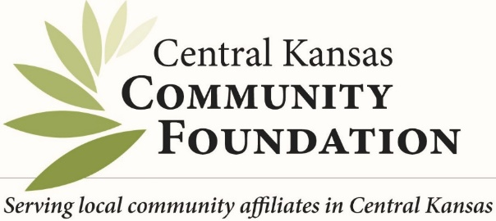 AFFILIATE LOGO HERE
FOR IMMEDIATE RELEASE
CONTACT:
PHONE:
EMAIL:
TITLE
(TOWN, KS – Month, Day, Year)

BODY
HISTORY OF FUND
QUOTES FROM BOARD MEMBER
Pictures
Statement of Action - Contact us for more information about the foundation or make a contribution to….
####
ABOUT AFFILIATE
BLURB>>>>>>>>>

ABOUT CENTRAL KANSAS COMMUNITY FOUNDATION
Central Kansas Community Foundation mission is “Building Stronger Communities Through Charitable Giving.” Founded in 1994 Central Kansas Community Foundation based in Newton, Kansas is an intermediary between donors and charities, the community foundation helps donors establish funds that financially support meaningful, charitable programs and services in their community. Central Kansas Community Foundation also host numerous affiliate community foundations throughout Central Kansas. www.centralkansascf.org

