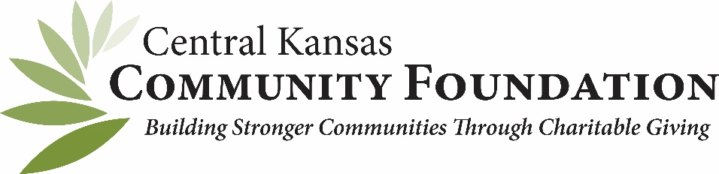
October 2017 Affiliate Facebook SUGGESTIONS
iMAGES
October is a good month to promote the activities that are happening in your community that you either sponsor or are involved with. Festivals, Halloween walks and chili-cookoffs are good opportunities to get pictures with key stakeholders and donors. When posting photos to your page in reference to your events, tag the people in them and use a # (hashtag) such as #pcfforthechiliwin or something clever. Encourage your friends to post using the same hashtag. The hashtag will create a link to newsfeed containing images and posts using this hashtag!
POSTS
- Fall is finally here! As the days get longer and the evenings are cooler, now is a good time to consider planning your estate. <link to http://ckcflegacy.org/>
- We wish all our friends and trick-or-treaters a safe Halloween! <Post a photo of your board or staff in Halloween costumes.>
- Get out for your October board meeting and document it. You can visit a pumpkin patch, take a hay-rack ride or have your meeting at a coffee shop. Feature photos of decorated pumpkins or latte art. Be sure to tag the coffee shop or pumpkin patch in your post.
ARTICLE
Year-End Giving
Options for Year-end Giving If you are like many of us, you are looking to save money on this year’s taxes. There are ways to make a year-end gift, other than a cash gift, and still enjoy valuable tax benefits. Here are just a few of the options you might want to consider for your end-of-year planning:
Gift of Your Property Do you have CDs, stocks or bonds that are producing little or no return? Why not make a gift of these low-performing assets to us, and receive a charitable deduction? You can also give your real estate, art or other property, and benefit from a deduction.
Gift of Your Property for Income If you are looking for income in the future, why not make a gift of property to fund a charitable gift annuity or charitable remainder trust? Your property can be sold taxfree, and you may receive income for the rest of your life. With a charitable gift annuity, this income is fixed so there is the possibility that some of your payment will be tax-free.
Future Property Gift Did you know there are gifts everyone can make to benefit from charitable giving? If you don’t want to give your stock or real estate today, you can still enjoy your property during your lifetime while making a gift to us through your will or trust. A bequest of your property will provide your estate with an estate tax charitable deduction, which means the money saved can go to your loved ones.
To learn more about these options for end-of-year gifts, or to view an illustration of the benefits of making a gift of your property, please call or click today. We look forward to helping you meet your year-end goals!

