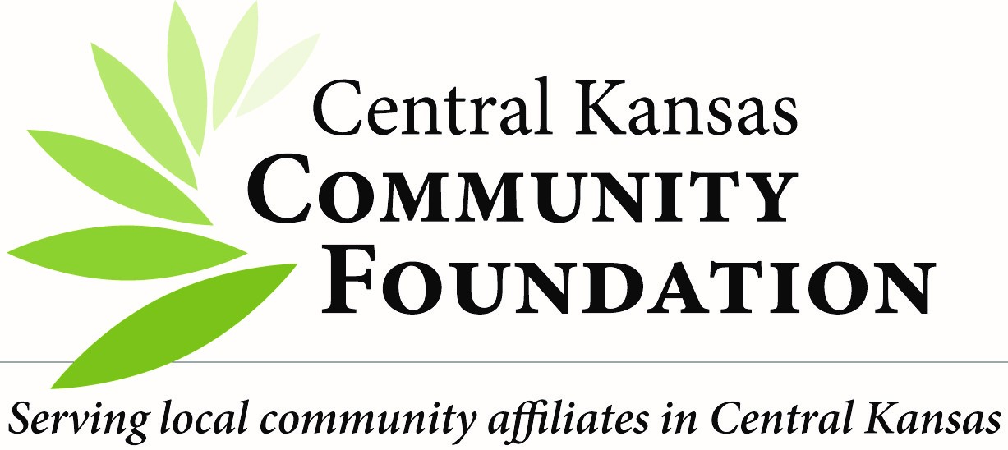
VOLUNTEERS SERVING YOUTH
INVITATION TO APPLY

THANK YOU for your interest in volunteering with your Community Foundation. Central Kansas Community Foundation is a host foundation to 20 affiliates in our Central Kansas service area. Our services rely heavily upon volunteers and could not succeed without them. You are receiving this packet due to the Foundation being notified about your interest to support an event or activity which specifically involves YOUTH or anticipates that opportunity.
Our Mission: Building Stronger Communities Through Charitable Giving
Because of the nature of our not-for-profit organization, our volunteers are required to complete an Annual Compliance Document Packet. This packet includes policies pertaining to Confidentiality, Conflicts of Interest, Photo Consent, Child Safety and More. If you have not reviewed and e-signed these documents in the past year, you can find the packet at https://ckcf.wufoo.com/forms/ckcf-compliance-documents-20192020/ . Volunteer relationships are “at will” as there could be circumstances resulting in the foundation terminating this relationship.
Additionally, since you are pursuing a volunteer role involving interaction with YOUTH (those under the age of 18) the Foundation has a requirement to have a CKCF criminal background check administered by our contracted provider, before volunteering in such a capacity.
As a courtesy we wanted to make you aware before your application through the CKCF Criminal Background Check Process of some criminal offenses that would disqualify your application for volunteering with YOUTH activities.
The offenses include but are not limited to Abduction, Assault, DUI, DWI, Embezzlement, Murder, Rape, or Statutory Rape. Candidates currently on Probation, Parole or have outstanding warrants will be denied opportunities to volunteer with YOUTH activities.
We are providing you those examples so you are more aware of criminal circumstances which will exclude you from Volunteering with YOUTH, you can rescind your application before the Criminal Background Check is administered.
The CKCF Safety Committee will review the results of each background check for those who apply and form a final decision on your approval/denial as a volunteer for the Foundation.
If you are not approved based on some result of your background check, there is a dispute process that you will be provided information regarding at the time of a denied application. For those that receive a positive application response they will receive a Secure Volunteer Card that they can show as confirmation of your volunteer status approval. Approved volunteer background check results will be in effect for 3 years.
We are successful because of our volunteer pool. We value your investment to your local community!
CKCF Safety Committee
Angie Tatro Kristie Diller Anthony Roy Mary Martha Good Jennifer Vogts
Service Area: Central Kansas Community Foundation | Augusta Community Foundation | Douglass Community Foundation | El Dorado Community Foundation |Elk County Community Foundation | Florence Community Foundation | Franklin D. Gaines & Beverly J. Tipton Foundation | Fredonia Area Community Foundation | Goessel Community Foundation | Halstead Community Foundation | Hesston Community Foundation | Hillsboro Community Foundation | North Newton Community Foundation |Peabody Community Foundation | Second Century Library Foundation – Newton | Trinity Heights UMC Foundation | Valley Center Community Foundation | Walton Rural Life Center Charter School Foundation | Remington Area Community Foundation | Women’s Community Foundation
301 N. Main, Suite 200 | Newton, KS 67114
Phone: 316-283-5474 |Fax: 316-283-5489
www.centralkansascf.org

