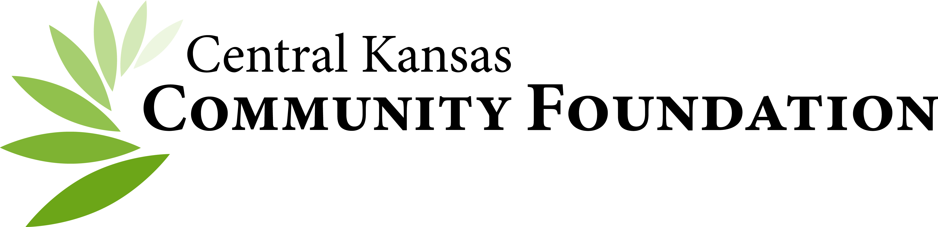

SOCIAL MEDIA POLICY

- Purpose
This policy governs the publication of and commentary on social media by employees, CKCF Board Members, Affiliate Board Members, Contractors and other Volunteers of the Central Kansas Community Foundation (the "Foundation"). For the purposes of this policy, social media means any facility for online publication and commentary, including without limitation blogs, wiki's, social networking sites such as Facebook, LinkedIn, Twitter, Flickr, and YouTube. This policy is in addition to and complements any existing or future policies regarding the use of technology, computers, e-mail and the internet.

Before engaging in community foundation-related social media, employees, contractors and volunteers must obtain the permission of the Executive Director or Marketing Communications Associate.

Publication and commentary on social media carries similar obligations to any other kind of publication or commentary.

All uses of social media must follow the same ethical standards that Foundation employees must otherwise follow.

Note of significance - Should any media representative(s) contact you in regard to a post on social media, or other foundation related announcement discuss with the Executive Director before making a public media response if it more than answering the specific facts from the approved communication they are referencing.

Setting up Social Media
For CKCF, its affiliates and donor representatives for funds in some cases may need assistance in setting up social media accounts and their settings. This can be obtained from our Marketing Communications Associate or the Executive Director. Admin Access must include the Executive Director or other designee at the CKCF administrative office, generally the Marketing Communications Associate.

Social media identities, logon ID's, hashtags and user names may not use the CKCF Foundation or Affiliate Foundation names without prior approval from the CKCF administrative office.

Confidentiality and Intellectual Property
It's perfectly acceptable to talk about your work and association with the Foundation and have a dialog with the community, but it is unacceptable to publish confidential information. Unless specifically authorized in writing by the Executive Director or CKCF designee, Foundation personnel are not authorized to, and therefore are restricted from, speaking on behalf of the Foundation through Social Media outlets, including media releases.

Foundation personnel, contractors, and volunteers (including CKCF and Affiliate Board members) must adhere to the Foundation’s Policy on Confidentiality in their use of Social Media. This means they may not discuss any confidential and/or proprietary work-related matters or information through Social Media. Likewise, these associates of the foundation may not post through Social Media, confidential and/or proprietary donor, grantee or Foundation-related documents, or post any information (including uploading pictures) that would violate the Foundation’s Policy on Confidentiality.

No photos, videos or likenesses are to be used without prior consent. Photo Consent forms are available through the CKCF office. The except is when Crowd Consent posters are used at public events like award ceremonies. Be sure to ensure they are posted at entrance(s) for participants to see and announce as able, to ensure those not wishing for their image to be used are honored.

Protect your own privacy
Privacy settings on social media platforms should be set to allow anyone to see profile information similar to what would be on the Foundation website. Other privacy settings that might allow others to post information or see information that is personal should be set to limit access. Be mindful of posting information that you would not want the public to see.

Be Honest
Do not blog anonymously, using pseudonyms or false screen names. The Foundation is committed to transparency and honesty. Use your real name, be clear who you are, and identify your relationship with the Foundation. Do not say anything that is dishonest, untrue, or misleading. If you have a vested interest in something you are discussing, point it out. But also be prudent about protecting yourself and your privacy. What you publish will be around for a long time, so consider the content carefully and also be cautious about disclosing personal details.

Respect copyright laws
It is critical that you show proper respect for the laws governing copyright and fair use or fair dealing of copyrighted material owned by others, including Foundation’s own copyrights and brands. You should never quote more than short excerpts of someone else's work, and always attribute such work to the original author/source. It is good general practice to link to others' work rather than reproduce it.

Respect your audience, volunteers, vendors and your coworkers
The public in general, and Foundation's employees and customers/clients specifically, represent a diverse set of customs, values and points of view. Don't say anything contradictory or in conflict with the Foundation website. Don't be afraid to be yourself but do so respectfully. This includes not only the obvious (no ethnic slurs, offensive comments, defamatory comments, personal insults, obscenity, etc.) but also proper consideration of privacy and of topics that may be considered objectionable or inflammatory - such as politics and religion. Use your best judgment and be sure to make it clear that the views and opinions expressed are yours alone and do not represent the official views of the Foundation.

Protect Foundation customers/clients, business partners, contractors and vendors
Customers/clients, partners, contractors or vendors should not be cited or obviously referenced without their approval. While it is acceptable to insert a link to their established page or hashtag, be mindful to never identify a customer/client, partner or supplier by name without permission and never discuss confidential details of a client’s engagement. It is acceptable to discuss general details about the kinds of projects and to use non-identifying pseudonyms for a customer/client (e.g., Customer 123) so long as the information provided does not violate any non-disclosure agreements that may be in place with the customer or make it easy for someone to identify the customer. Your personal blog is not the place to "conduct business" with a customer/client of CKCF or its Affiliates.

Controversial Issues
If you see misrepresentations made about Foundation in the media, please notify Foundation’s Executive Director immediately. Always do so with respect and with the facts. If you speak about others, make sure what you say is factual and that it does not disparage that party. Avoid arguments. Don't try to settle scores or goad competitors or others into inflammatory debates. Make sure what you are saying is factually correct.

Be the first to respond to your own mistakes
If you make an error, be up front about your mistake and correct it quickly. If you choose to modify an earlier post, make it clear that you have done so. If someone accuses you of an improper post (such as their copyrighted material or a defamatory comment about them), remove it immediately and notify Foundation’s Executive Director immediately.

Disclaimers
Many social media users include a prominent disclaimer saying who they work for, but that they are not speaking officially. This is good practice and is encouraged. However, it may not be legally binding.

Enforcement
Policy violations as an employee will be subject to disciplinary action, up to and including termination for cause. The Foundation reserves the right to take legal action against personnel who engage in prohibited or unlawful conduct. If you have questions about the terms of this policy, direct them to the Foundation’s Executive Director.
Violations by members of the board and other volunteers may lead to dismissal from the board or committee on which the volunteer serves.

