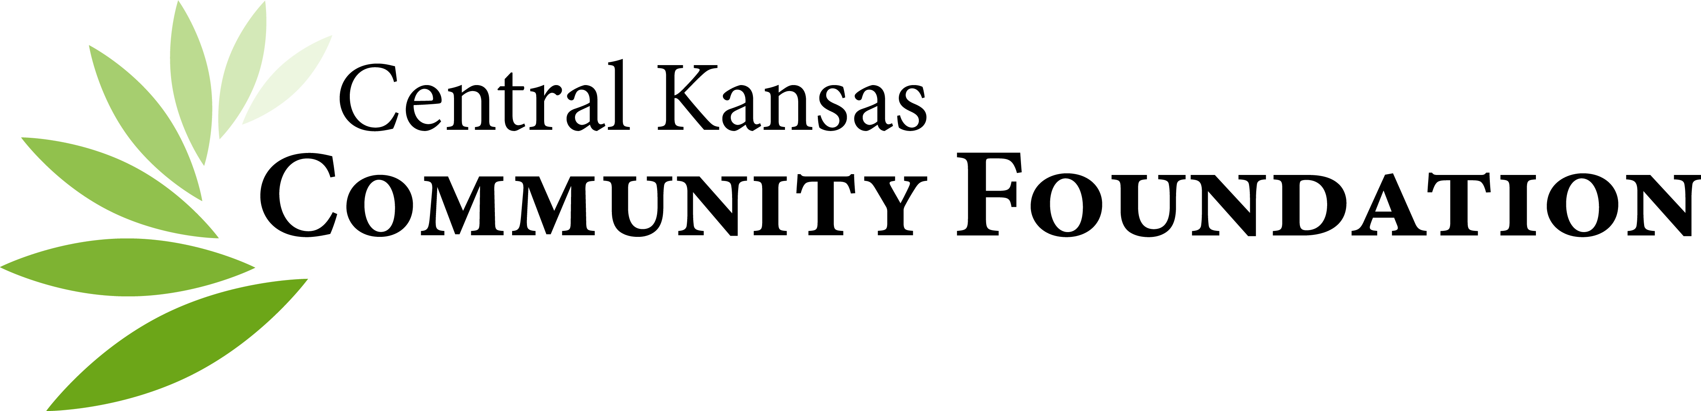

Prospective Director Profile

Name: Birthday:

Spouse’s Name:

Children’s Names and Ages:

Education: School(s) Degree(s)

Addresses and Phone Numbers:

Home Phone:

Fax:

Office: Phone:

Fax:

Email:

Preferred Mailing Address is: Home Office

Mailing Preference: Postal Email

Knowledge or Involvement with the Community Foundation:

Interest in serving on the Board of Directors:

Areas of Expertise or Strengths:

Affiliations: (Please note offices held, if any)

- Profit-making Organizations (present and past 5 years)

- Fraternal, Service and Professional Organizations (present and past):

- Non-Profit Organizations (Will be updated annually on the Conflict of Interest Form):

Potential Committee Interest:

- Executive
- Finance
- Governance
- Ad Hoc Special Events
- Ad Hoc ______________

Target: Board Profile Categories
Category | On Board | Recruitment Notes | I BRING
Financial Advisor | X
Banking | X
Attorney | X
City – County Government | X
Education | X
Farm/Ag |  | X
Funeral Home |  | X
Not for Profit | X
Real Estate | X
Faith Based | X
Healthcare | X
Development - Fundraising | X
Community Volunteer | X

Age Matrix
Category | On Board | Recruitment Notes | I AM
< 29 |  | X
30-45 | X
46-60 | X
61-75 | X
75 > | X

For internal office use only:

- Candidate has met with the Executive Director and

- Candidate has reviewed and agreed to the Board Member Job Description and Expectations

Nominator: Date Nominated:

Comments (Please use back):

